Chapter 7
- Please describe basis/main factors of sorting search results? Actually, search engines have thousands of ranking factors. Four kinds of sorting factors are as following.
- The similarity between the key words and the content of the web page.
- Results of web page quality evaluation
- User preference,
- Bidding situation from Enterprises with products.
Try your best to understand the analysis content of user preference in the following table(in Chinese).
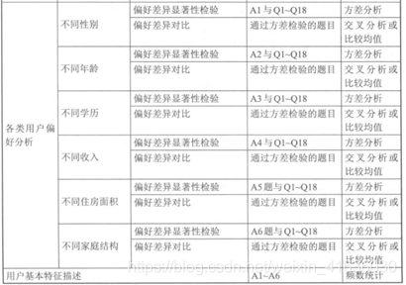
- Please describe there kinds of Information retrieval models.
- Boolean Model（布尔模型）
Boolean expression composed of keywords and logical operators that express the characteristics that the user wants the document to have.Its also known as Exact-Match Retrieval.

- Vector Space Model（向量空间模型）
vector space model of word item weight calculation in query word or document, the weight of word item in query word or document represents the importance of word item in query word or document.

- Probabilistic Model（概率模型）
retrieval useful to derive ranking functions.
-Used to take into account the impact of random events or actions in predicting the potential occurrence of future outcomes.

- In Boolean Model, how to express a query word?
Query word: a Boolean expression composed of keywords and logical operators.
- What are disadvantages of Boolean Model?
- Inconvenient query for users
- The results of Boolean Model can not be sorted. Because the result of Boolean Model only contain two types,related documents and unrelated documents.
- Low computing efficency. Because the exact matching between query and documents.
- Please describe Cosine similarity.
- The difference between cosine and inner product similarity lies in the normalization of inner product similarity.
- For cosine similarity, we can imagine that it first normalizes the document vector so that the sum of the weights in the vector corresponding to each document is 1.5%.
- The similarity of vector is only related to the angle, but independent of the length of the document.

- What is TF-IDF?
- TF： The frequency at which word items appear in this document or query word
- IDF： The reciprocal of the number of documents in which the word item appears in the document collection .

- Please describe some problems in the application of vector space model in search engine?
- Not matching between keyword vector and document vector, including the same concept in different terms.
- Different word items are not independent with each other.
- "Boundary effect" on the frequency of word items
- How to solve problems in the application of vector space model in search engine?
See ppt to find the answers.
- Please describe five steps for retrieve subsystem.
- Receive user query words;
- Get candidate result documents from inverted index table;
- Calculate various parameters that affect the sorting of retrieval results;
- Merge each parameter to get the final value used for sorting;
- Return the sorted result document to the user.
- Please describe the a classical query process based on the reverse index table.
- a database of text elements is compiled along with pointers to the documents which contain those elements.
- search engines use a process called tokenisation to reduce words to their core meaning, thus reducing the amount of resources needed to store and retrieve data.

